

**Major Project**

NUTRITIONAL TRACKER

**(Winter 2020)**

**Instructor:** Takis Zourntos

**Subject:** ESE-4009

|  |  |  |
| --- | --- | --- |
| **STUDENT NAME** | **STUDENT ID#** | **SIGNATURE** |
| Alpit Abrol | C0743865 | AA |
| Bhavna Sharma | C0742945 | BS |

TABLE OF CONTENTS

|  |  |  |
| --- | --- | --- |
| S.No | Content | Page |
| 1. | Introduction | 3 |
| 2. | Concept and Methodology | 6 |
| 3. | Hardware Architecture | 7 |
| 4. | Software Architecture | 8 |
| 5. | Project Price Estimation | 11 |
| 6. | Further Advancements | 12 |

NUTRITIONAL TRACKER

INTRODUCTION:

A diet, of course, an approach to live longer and healthy life. There has been always a debate over the concept of healthy eating habits ever since human evolution. For example, “OH my god, one scoop of fruit ice-cream will give me 137 calories. I can’t have it.” are the most dramatic lines used by most of the health-conscious people around the world. Those people are only aware about its 1.6 grams fat in the ice cream but they are absolutely clueless about its protein content as in healthy practice. A fascinating research was published recently by WHO which clearly depicted the people’s intake of required nutrients for a body is declining day by day. The described reason was lack of awareness about recommended balanced diet.

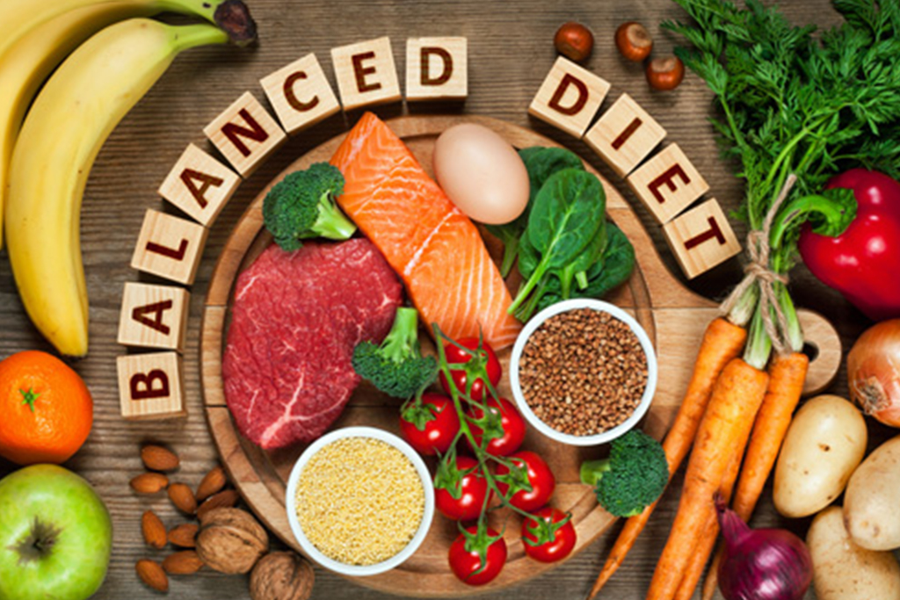

In the world of calories advertised by every other company product, nutrients such as vitamins and minerals been always in the dark. Nevertheless, it is estimated that number of premature deaths are directly attributable to obesity and vital diseases which is again based on the one’s negligent approach towards his diet. A diet with healthy intake of every nutrient in its balanced and recommended way is fruitful for humans in every stage of life. For a healthy life, fundamental strategy needs to be modified. In this project, we will focus on the modified strategy to complete the balanced diet for various ignorant and enthusiastic people. This dietary assessment tool will be convenient way for those people such as Alpit Abrol who wants to keep a track on their balanced diet. The project will follow a particular stream line of steps which will help people to complete their essentials in a day.

**WHAT IS IT?**

This project is a kind of grocery assistant in the form of excel sheet which will keep a full-on track what exactly you have bought in your grocery every time and what you have to buy next time for your grocery. According to 5-a-day Campaign by WHO, everyone should at least have 5 portions of different of fruit and vegetables every single day. This whole guide will emphasize on the concept of balance of every portion required for your body’s nutritional needs. This project will allow user to **get the nutritional information** and **guidance to follow a food pyramid by just clicking a picture**. On the basis of how much grocery shopping has done in a visit, it will describe the user that he has to come again for the shopping along with the options of what **he has to buy next time to complete his nutrition value for the week.**

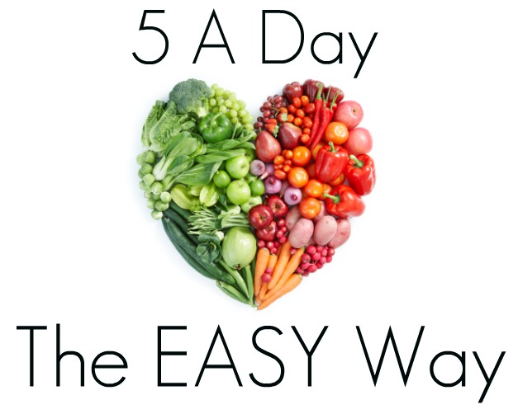

This application allows

user to get nutrient information of products and grocery by

just taking a phot

This application allows

user to get nutrient information of products and grocery by

just taking a phot

This application allows

user to get nutrient information of products and grocery by

just taking a phot

How this project is helpful for Individuals?

* This is kind of **nutritional tracker**. This project will definitely **assist** you to **figure out** your **items for grocery** basket which will be completely nutritional.
* This project will help those people who are completely unaware of the concept of balanced diet. Undoubtedly, it will direct you to what to buy next and when just to complete your **daily nutritional level.**
* Another advantage is that it will help user that what time he has to go for the shopping.

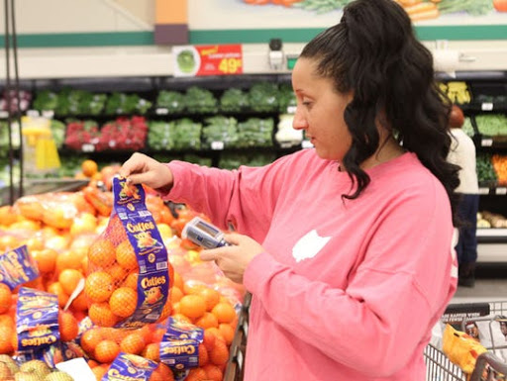

CONCEPT AND METHODOLOGY

application makes use of the smartphone camera

capabilities to capture the image of the grocery item or the

product image and its nutrition fact table (NFT). After

uploading the image, we use the image processing and cloud

technology to process, analyse and store the useful

information obtained. A client-server architecture is best

suited for this type of application. We have used an Android

smartphone as a client, and Node.js for the server. The image

processing is done using OpenCV. Parse is the cloud

database provider

This embedded project is the combination of the hardware and software system.

1. Hardware System: Hardware system is defined as **product code canner unit** which will help user to click the image from camera and send it automatically to the software.
2. Software System: Software part is code **processing and display unit** which will process the image and define the features of the whole project. Even, the hardware part will also be programmed which will be considered under this unit only.

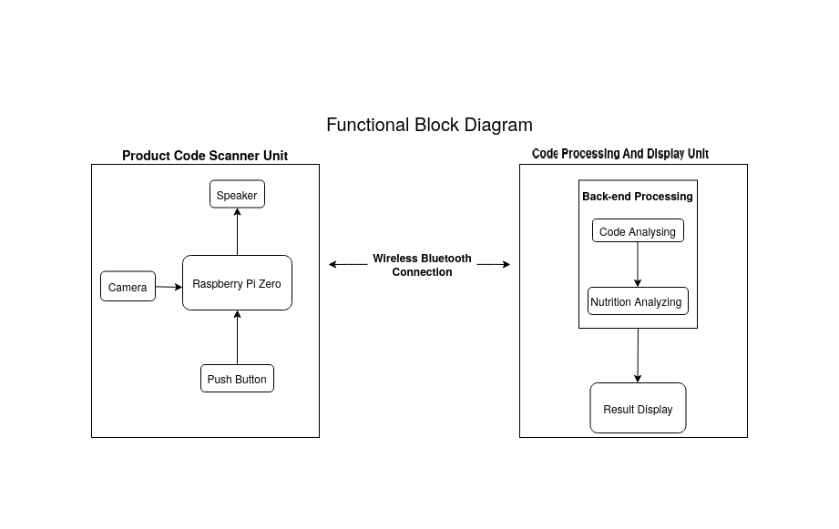

fig: Functional block Diagram

HARDWARE ARCHITECTURE:

This part will aim to develop a product scanner unit. The hardware system includes the capturing of the image of the grocery item or the product code which will be done by using the Raspberry PI Camera by interfacing through a USB to the raspberry pi by just pressing a push button. Raspberry PI is the main basic building block of the whole hardware which will help user to click a picture while buying grocery for some amount of time.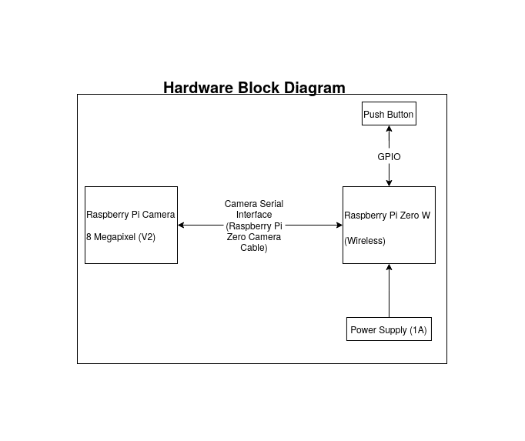

fig: Hardware block Diagram

SOFTWARE ARCHITECTURE:

In this project, the software architecture is divided into two parts.

1. **Product Code Scanner Unit** is also required to be programmed. In this, pre-defined API will be used for the main function. The thread will be programmed accordingly to make sure that button is pressed and it will send signal to camera to send picture.

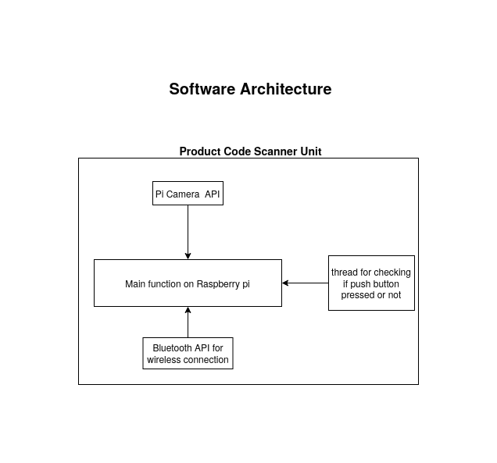

fig: Software Block Diagram :01

1. **Processing and Display Unit:** In this unit, number of tasks will be defined to make sure the image is processed properly.

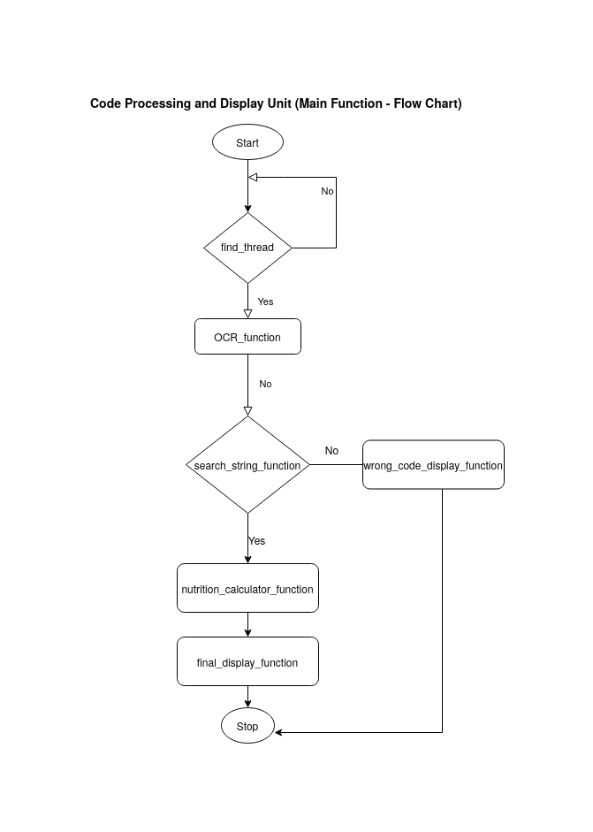

* Find_thread: It will keep on checking that Bluetooth has received a picture or not.
* If the image is received it will to the OCR-function.
* OCR_function: Then, image will be converted into texts here.
* Search-string function: It will find the particular strings required from the database of fruits and vegetable codes.
* Wrong_code_display function: It will display that code is not there in the database if user will scan wrong code.
* Nutrition_calculator function: this will calculate nutrition of the items and process it accordingly.

HARDWARE COMPONENTS (ESTIMATION OF PROJECT)

This part will explain the estimation of the whole project. The whole components will cost us 82 CAD.

1. Raspberry Pi Zero Wireless Board ($12.95)
2. USB OTG Cable ($5.49)
3. Raspberry Pi 3 Power Supply-1a ($9.95)
4. Mini HDMI Adapter ($5.49)
5. Raspberry Pi Camera- 8 Megapixels ($39.95)
6. Raspberry Pi Zero Camera Cable ($7.95)

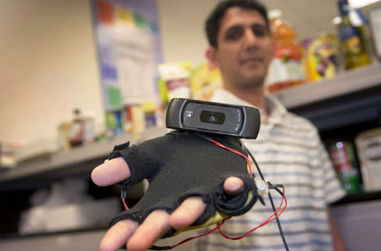

FURTHER ADVANCEMENTS:

In this whole description, we are still working on the advancements of the software. The whole software part needs to be taken in consideration and work will be done step by step to make the project more convenient for the user.